Zoom User Guide

You can access the meeting via the web by going to https://us04web.zoom.us/
Or by Downloading the Zoom APP onto your phone/Tablet

Step 1 for access via zoom website:
- Type in: https://us04web.zoom.us/ Press enter
- Click on the Join A Meeting Button
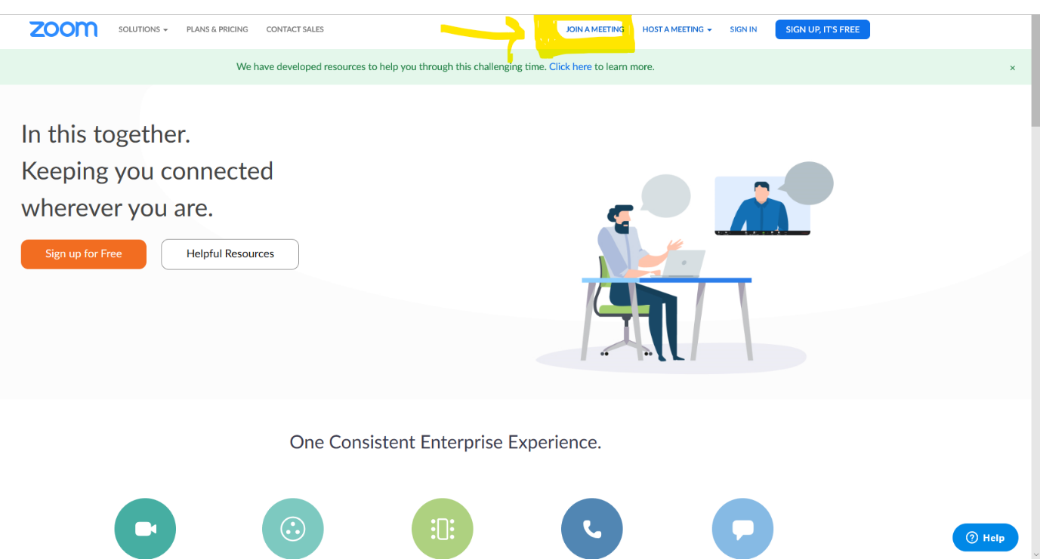

Step 2

- Enter the Meeting ID number E.g. 000-000-000 you were sent via email
- Click Join

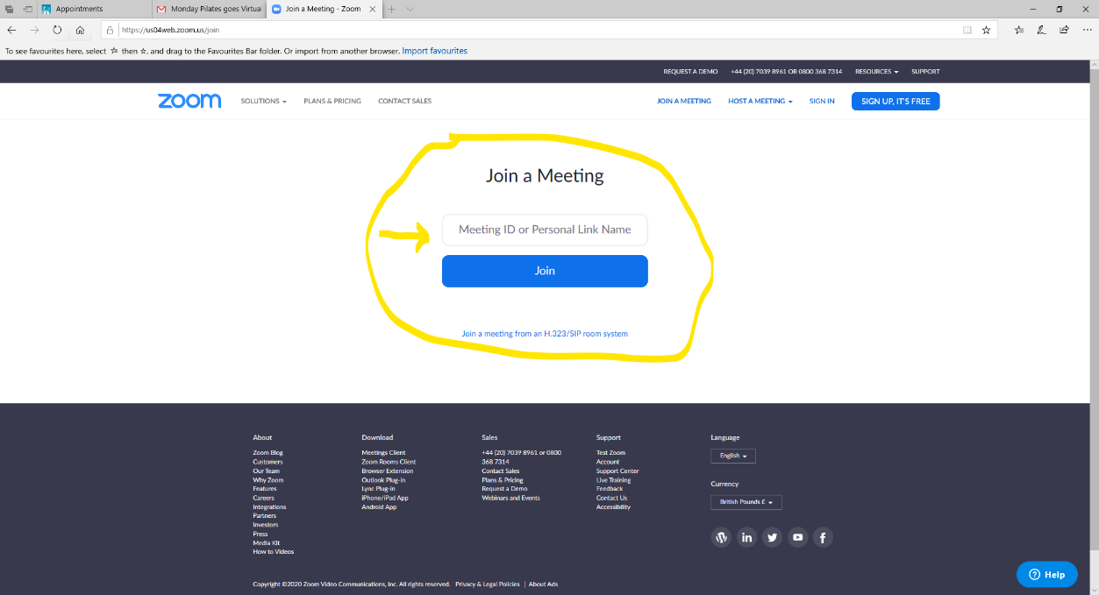

To download the free Zoom App:
- Go to your Ap store
- Search for Zoom App
- Download the Zoom App as pictured below for free before your session time

To Access via the Zoom APP:

Step 1: Open the Zoom App
Step 2: Click on the Join meeting button, Enter the meeting ID you were sent via email and click Join
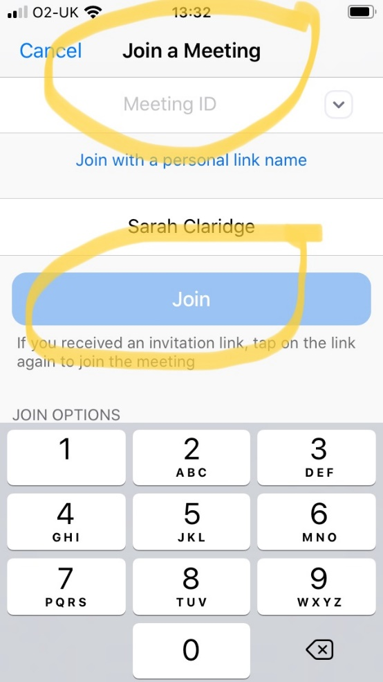

To mute yourself click the bottom left corner Mute button

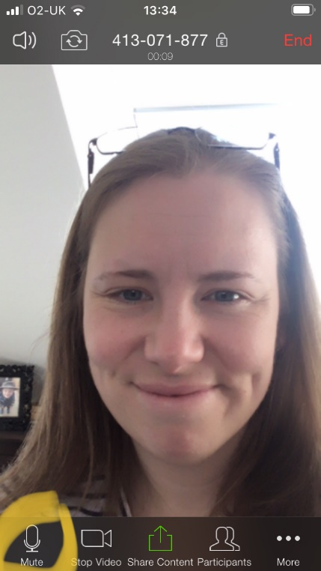

To speak, swipe right and tap on the Tap to Speak button

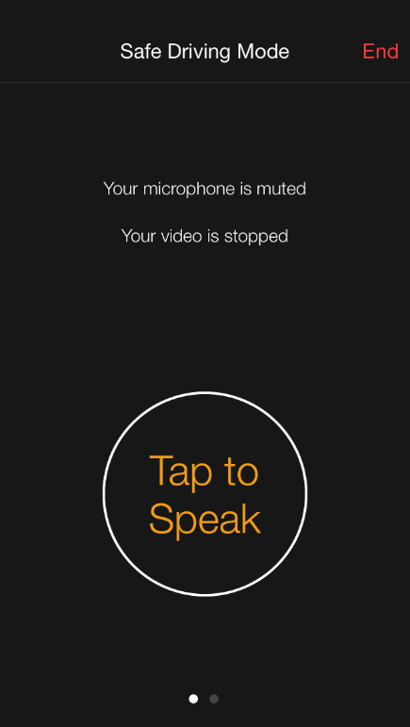

To end the session click the top right part of the screen with your finger and the End word will appear, click to End.

